COMSATS University Islamabad, Abbottabad Campus

**Department of Computer Science**

**LabAssignment#01 – Spring-25**

Class: BSEB Date: **16/04/2025**

Subject: **Computer Networks** Total Time Allowed: **60 minutes**

Name: **Okasha Khan** Registration # **Sp23-bse057**

# Submission Deadline Time allowed: 90 minutes

The deadline for the submission of assignment is, **Wednesday April 16th 2025, 12:00 PM** on CUOnline portal after the end of Lab in PDF form only. Nobody is allowed to send assignment through emails. Late submission is extremely discouraged and won`t be marked.

**TOPIC:** Attempt the following tasks in CISCO packet tracer. Add screen shots of all tasks in the solution file. Use this format for assigning a class C IP address at each node in the assignment 194. (your reg #).7.0 (IP Range 1-99). For example, 194.110.7.5.

**(CLO-5(PLO2-C3)**

Q 1) Create the scenario using four(4) PCs, two(2) switch, and two(2) servers.

1. Configure the router
2. Configure the DNS server
3. Configure Web Server with four web pages

**Important Instruction:**

Title page should NOT be attached. You can write your names, reg no in headers/footers.

The assignments will not include any Page borders. The page margins would be of standard A4.

Use proper labelling and required description for each screen shot/activity in MS word file, convert it into

PDF.

**LAB ASSIGNMENT 1:**

**Router Configuration:**

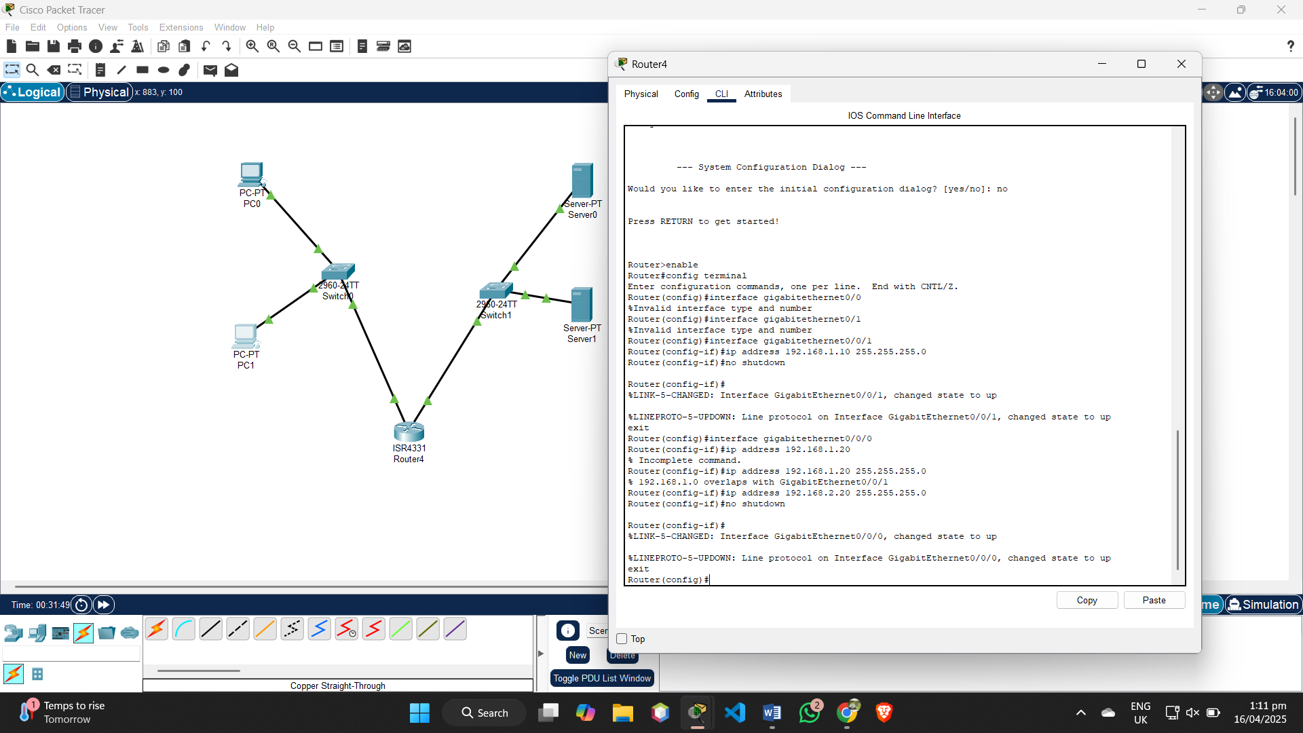

DNS Server Configuration:

Pc 1:

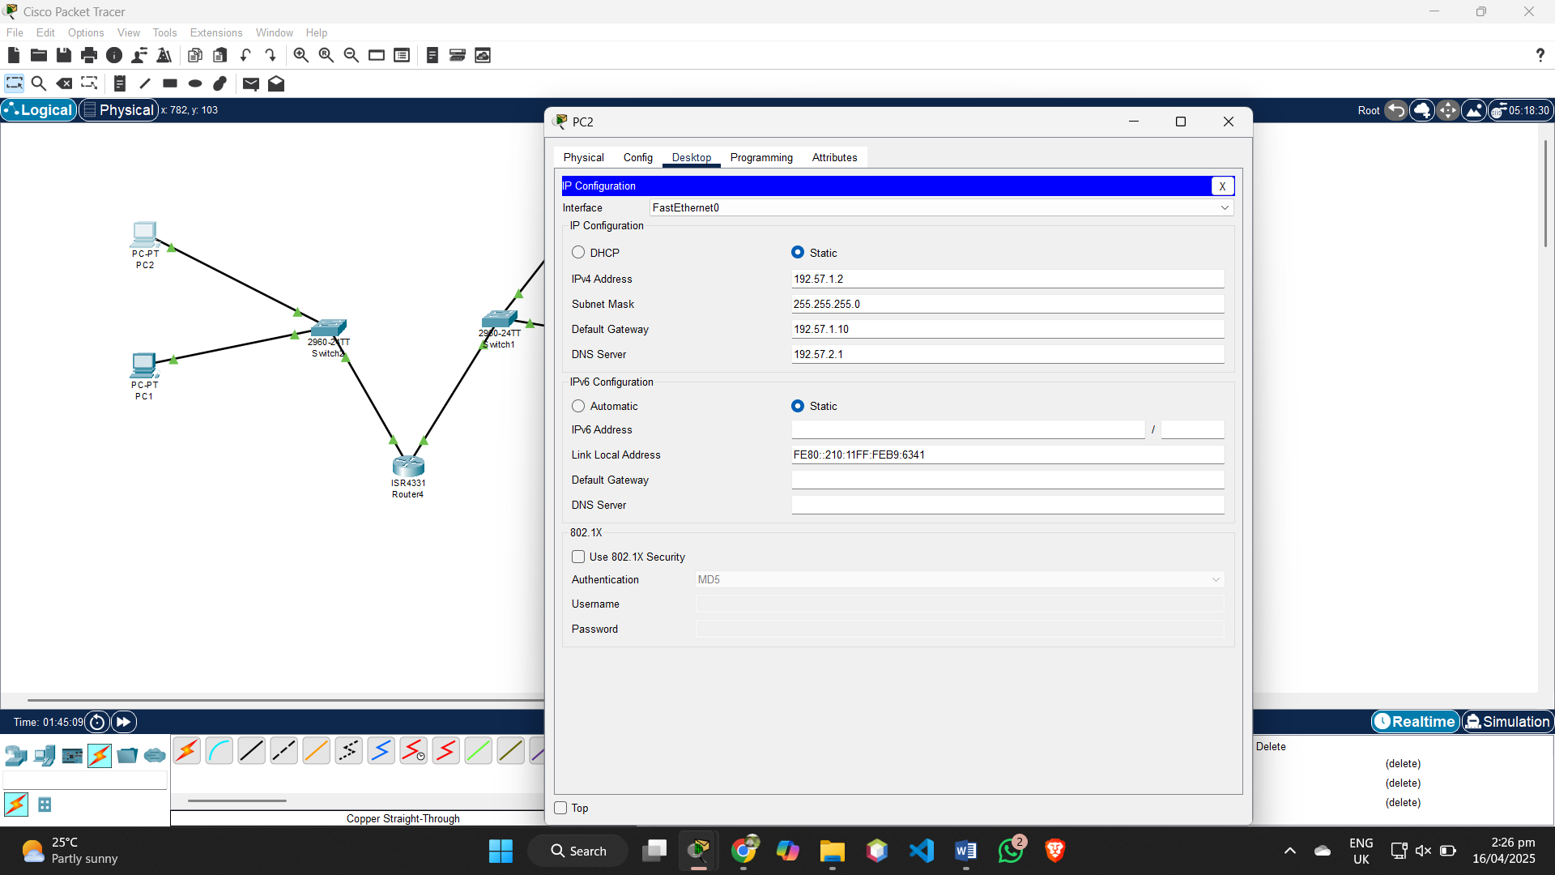

Pc2:

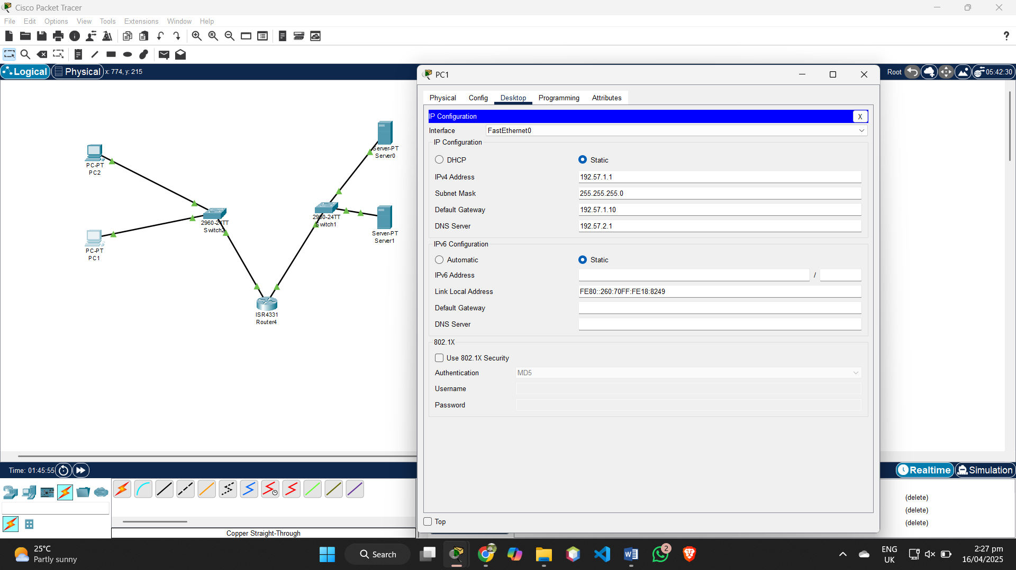

Dns server:

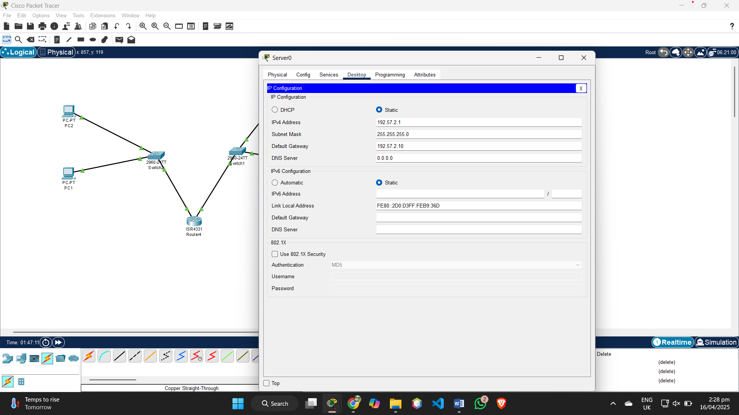

Web server:

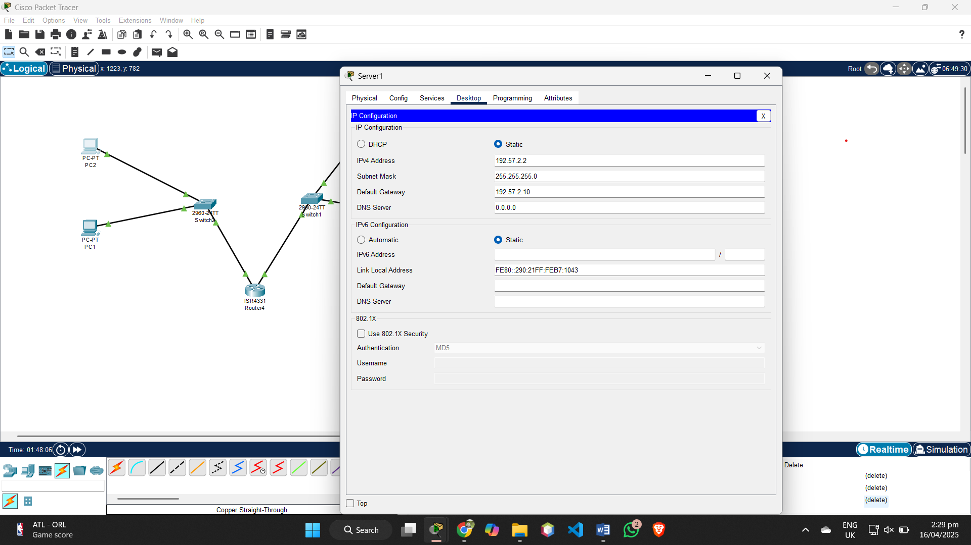

**WEB PAGE:**

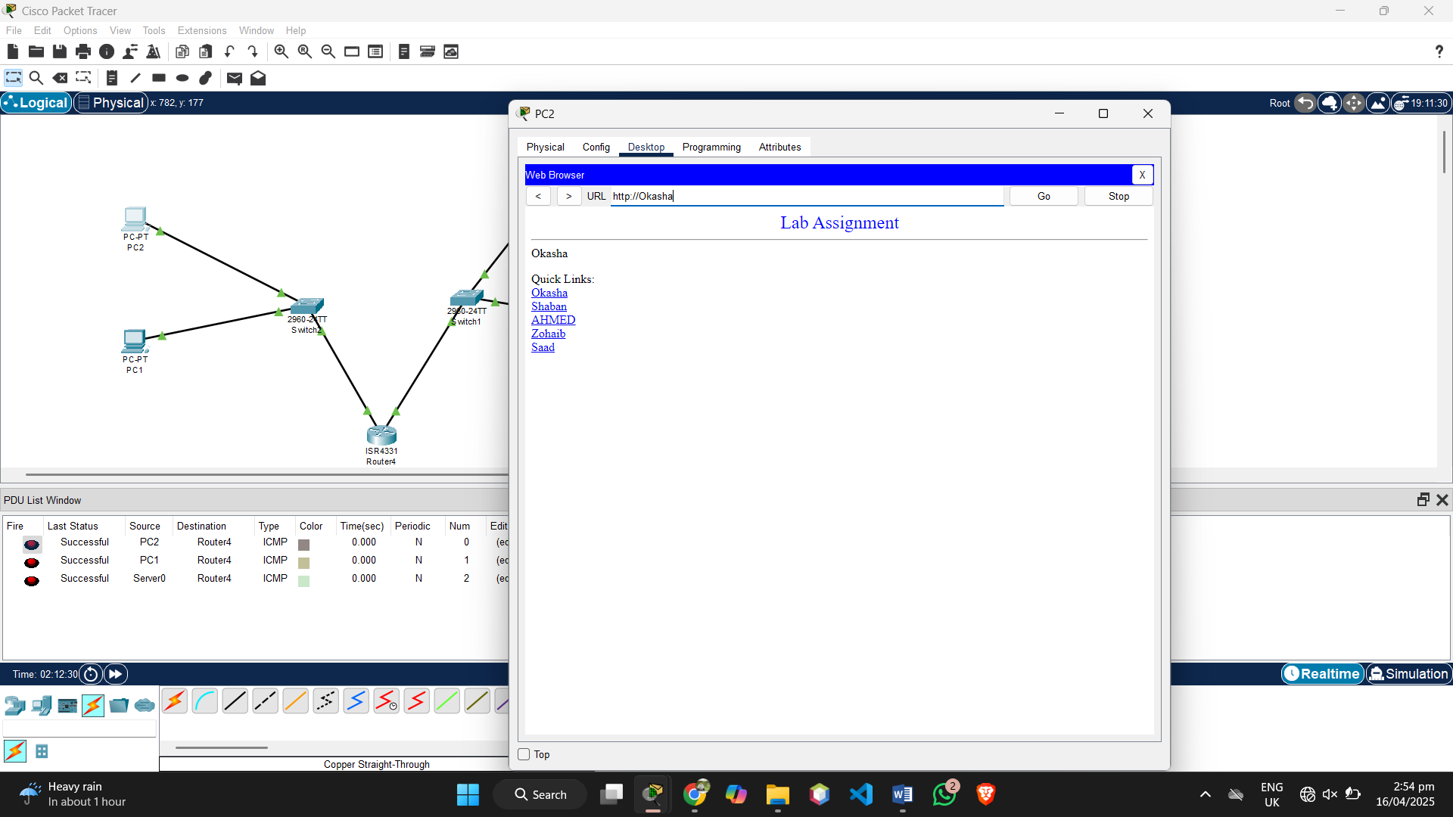

Page1:

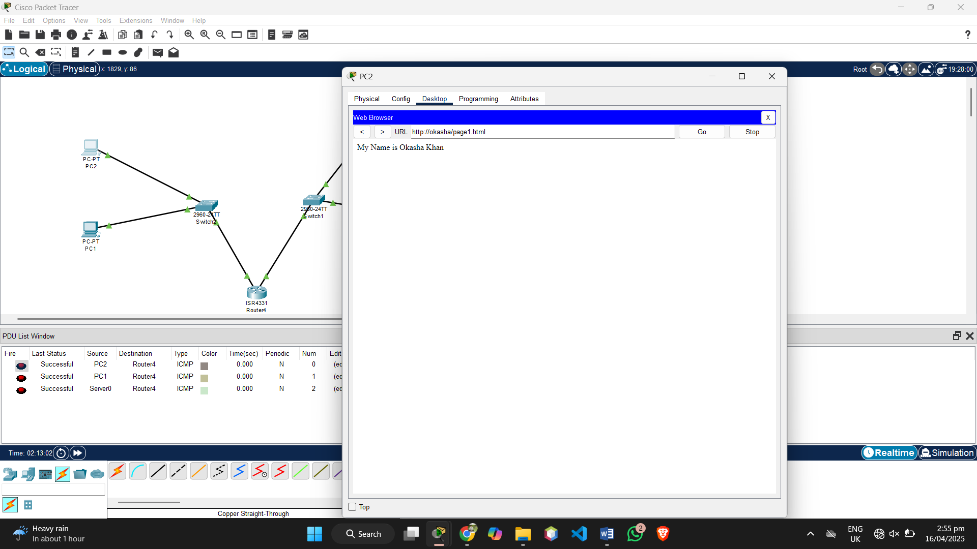

Page 2:

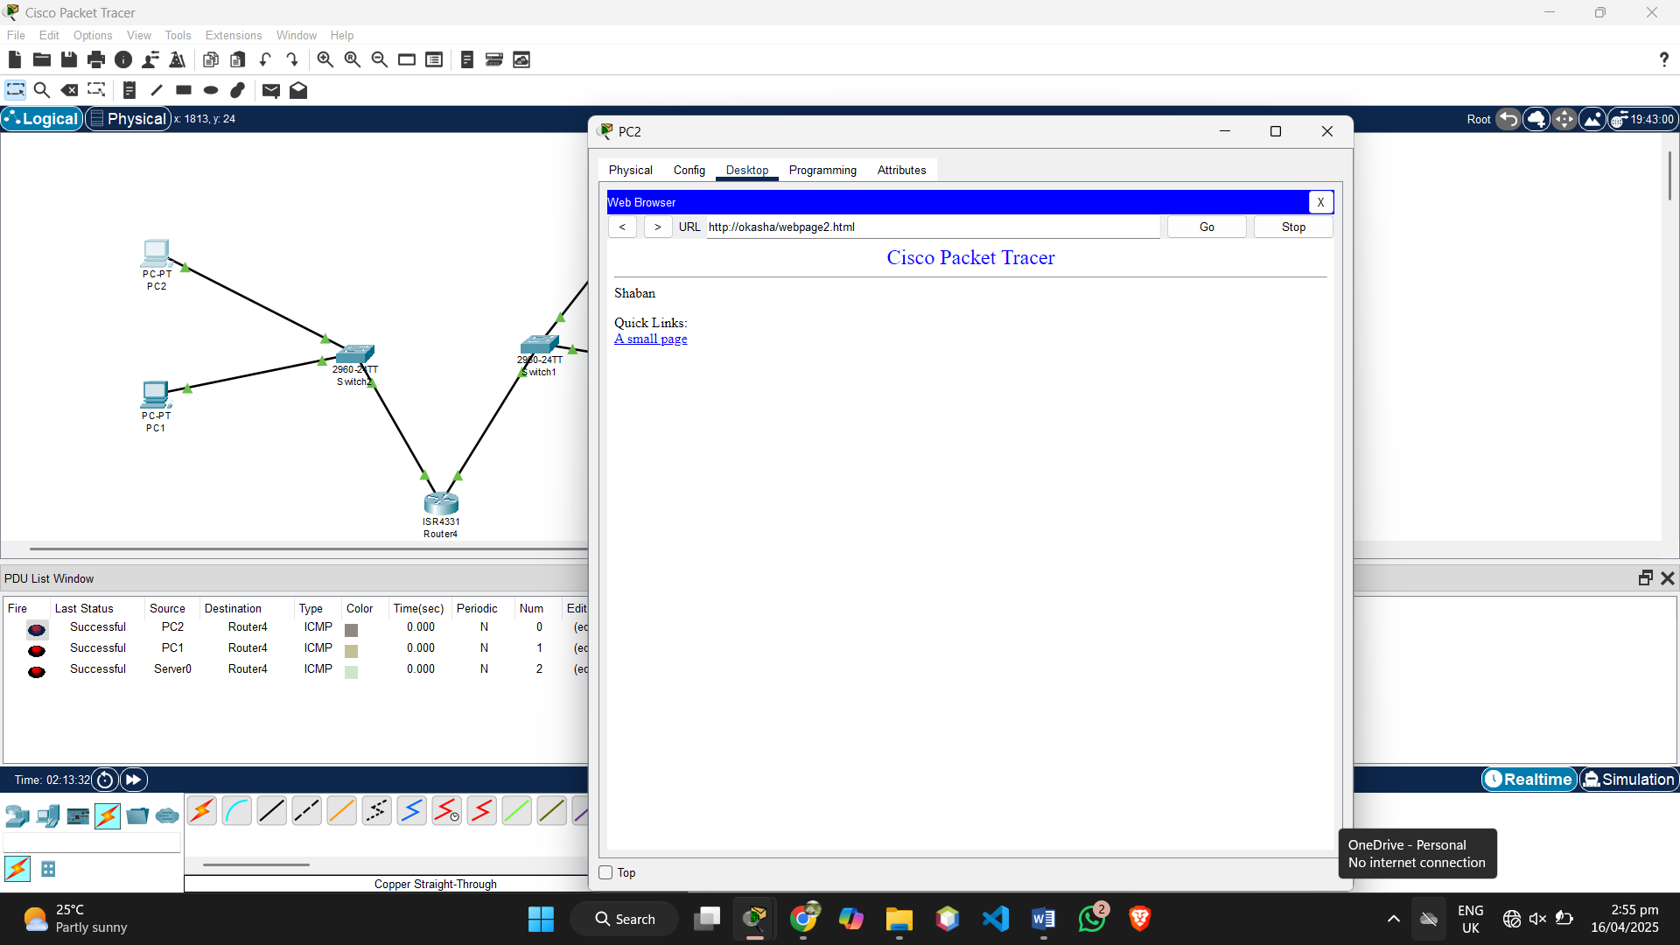

Page 3:

